Step 1: Click on ‘Reimburse myself’

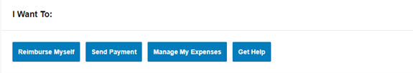

Step 2: Fill out the ‘Pay From’ & ‘Pay To’ drop downs & click ‘Next’

\*\*The ‘Pay From’ drop down will only give them the option to choose MEDICAL\*\*

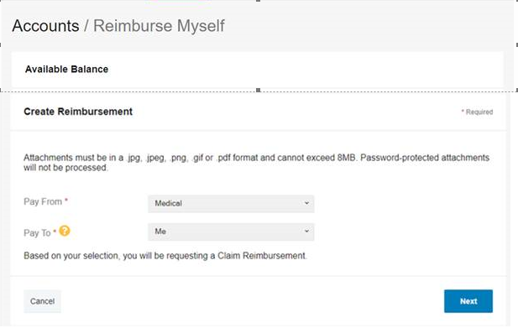

Step 3: Upload Valid Documentation & click ‘Submit’

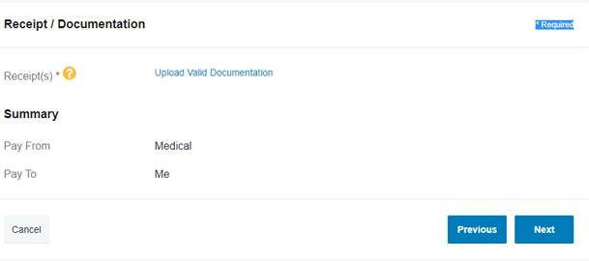

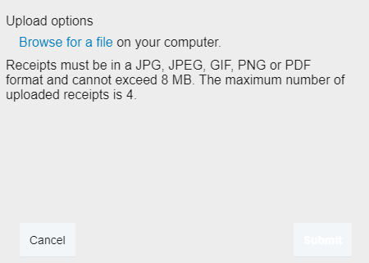

Once you click ‘Submit’ you will receive confirmation

Step 4: Once documentation is uploaded click ‘Next’

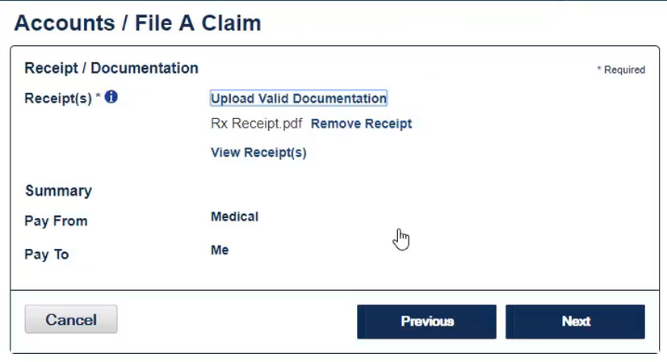

Step 5: Fill out ‘File a Claim’ Information & click ‘Next’ – enter ‘Medical’ as the Category

**\*\*\*”Type’-MUST BE ‘medical deductible’ \*\*\***

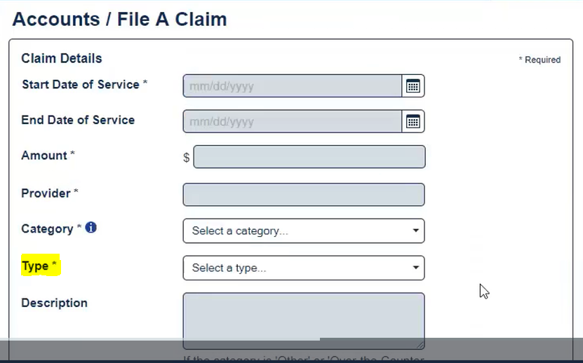

Step 6: Check the Terms & Conditions box and click ‘Submit’

